


Scope and Storyboard for Defence Allocation and Directions

AMR Manchester

By GQL

Table of Contents

1. Document Revision History 2
1.1. Document Location 2
1.2. Revision History 2
1.3. Approvals 2
1.4. Distribution 2
2. Summary of Scope 3
3. Screen design 4
4. Workflow 22
5. Navigation 25
5.1. Where will the Flow be launched from 25
5.2. Where should the Flow return to 25
6. SQL Tables 25
6.1. Table 25
n/a 25
6.2. Lookup 25
The following new key date type are required: 25
6.3. Field 25
n/a 25
7. Stored Procedures 25
7.1. Fetch 25
7.2. Save 26
8. Document Templates 28

Document Revision History

Document Location
Full File Path
/tmp/lo/0000.doc

Revision History
Version Number | Revision Date | Summary of Changes | Changes marked | Author
0.1 | 04/02/2010 | First issue | N/A | GQL
0.2 | 11/02/2010 | Second draft with alterations from LMW | Yes | GQL
0.3 | 18/07/2011 | Third Draft with Amendments from Zurich | No (Too Many) | GQL
0.4 | 25/07/2011 | LMW Amendments | Yes | LMW

Approvals
Name | Signature | Title | Date of Issue | Version

Distribution
Name | Title | Date of Issue | Version

Summary of Scope

The purpose of this scope is to outline the provisions that the FloCase system will need to make to allow users to handle the process of filing a Defence, receiving an Allocation Questionnaire, filing an Allocation questionnaire and receiving Directions and then subsequently dealing with those Directions appropriately.

It is envisioned that whilst the process itself may be of a complex nature the system should provide a simplified generic solution that merely tracks dates and has a certain amount of supervision inbuilt to assist the Team Leaders in ensuring key tasks involved in these process are dealt with in a timely manner.

Screen design

  - Defence

    - Defence – Details of Proceedings (Form 1)

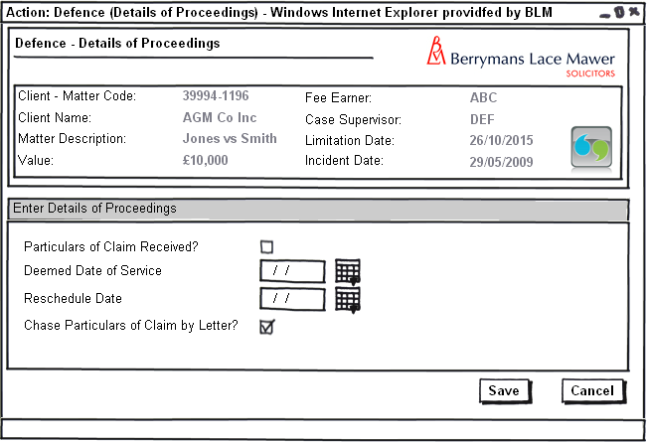
Figure 1 – Particulars of Claim not received

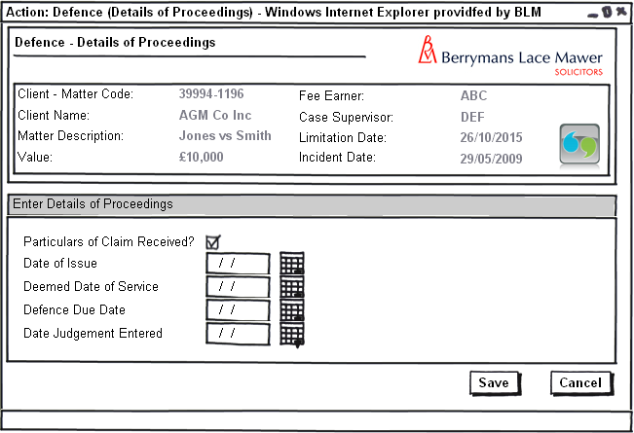
Figure 2 – Particulars of Claim received

Form Availability
Form should be available for selection adhoc from the Case Action screen

Form Behaviour On Load
The form should load with data previously entered Pre-Populated via a New stored procedure LTMM_DefenceDetails_Fetch as follows:

- Particulars of Claim Received? Map to DefenceDetails_POCRec
- Deemed Date of Service Map to DefenceDetails_DDService
- Date of Issue Map to DefenceDetails_DateIssue
- Defence Due Date Map to DefenceDetails_DefDueDate
- Date Judgement Entered Map to DefenceDetails_DateJdgEntrd

Form Items
Particulars of Claim Received? – Label as stated with associated checkbox

Deemed Date of Service – Label as stated with associated Date Picker, Mandatory field.

Reschedule Date – Label as stated with associated Date Picker. This control should only be visible if Particulars of Claim Received? = Unchecked, Mandatory field if Visible.

Chase Particulars of Claim by Letter? – Label as stated with associated checkbox. This control should only be visible if Particulars of Claim Received? = Unchecked.

Date of Issue – Label as stated with associated Date Picker. This control should only be visible if Particulars of Claim Received? = Checked, Mandatory field if Visible.

Defence Due Date – Label as stated with associated Date Picker. This control should only be visible if Particulars of Claim Received? = Checked, Mandatory field if Visible.

Date Judgement Entered – Label as stated with associated Date Picker. This control should only be visible if Particulars of Claim Received? = Checked.

Form Behaviour on Submit
Should return to the Matter Landing Page.
If Particulars of Claim Received? = Unchecked – Schedule Defence – Details of Proceedings (Form 1) for Team Administrator on the Matter for either the Reschedule date, if one entered, or the Deemed Date of Service.
If Particulars of Claim Received? = Checked – Schedule Defence – How to Proceed (Form 2) for Lawyer on the Matter.
If Particulars of Claim Received? = Checked – Produce an Acknowledgment of Service document.

Use New Stored Procedure LTMM_DefenceDetails_Save to save the following details entered on the form:
- Particulars of Claim Received? – Map to @pDefenceDetails_POCRec
- Deemed Date of Service (Key Date) – Map to @pDefenceDetails_DDService
- Date of Issue (Key Date) – Map to @pDefenceDetails_DateIssue
- Defence Due Date (Key Date) – Map to @pDefenceDetails_DefDueDate
- Date Judgement Entered (Key Date) – Map to @pDefenceDetails_DateJdgEntrd

Form Behaviour on Cancel
Return to Case Actions screen

    - Defence – How to Proceed (Form 2)

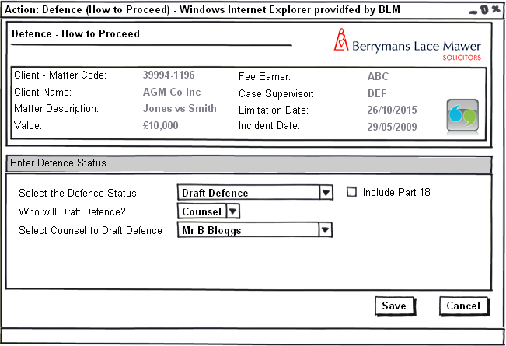
Figure 3 – Defence – How to Proceed (Draft Defence)

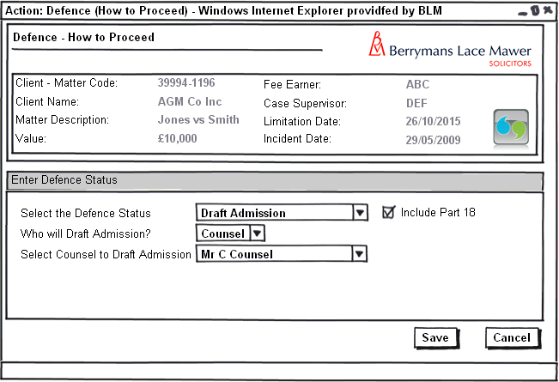 Figure 4 – Defence – How to Proceed (Draft Admission)

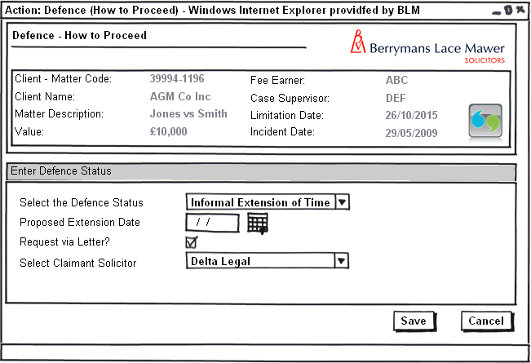 Figure 5 – Defence – How to Proceed (Informal Extension of Time)

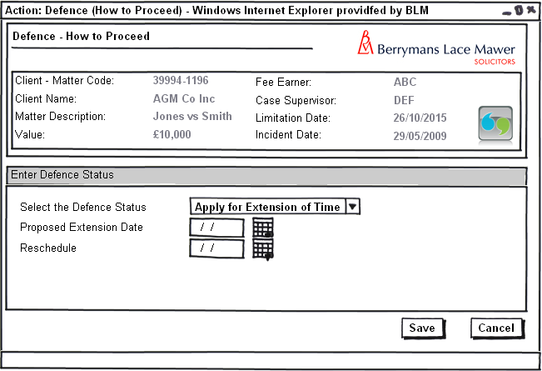
Figure 6 – Defence – How to Proceed (Apply to Extend Time)

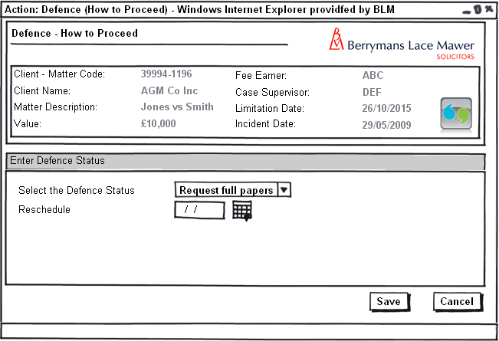 Figure 7 – Defence – How to Proceed (Request full file of papers)

Form Availability
Form should not be available for selection adhoc from the Case Action screen but scheduled from Defence (Details of Proceedings).

Form Behaviour On Load
The form should load with data previously entered Pre-Populated via a New stored procedure LTMM_DefenceDetails_Fetch as follows:
- Select the Defence Status Map to DefenceDetails_DefStatus
- Include Part 18? Map to DefenceDetails_Part18
- Proposed Extension Date Map to DefenceDetails_PrpsdExtnDate

Form Items
Select the Defence Status – Label as stated with associated Mandatory Combo box having the following options (Populated using LTMM_LookupCodes_Fetch with @LookupTypeCode = 'DEFSTAT', @BlankRow = 1):
- Draft Defence
- Draft Admission
- Informal Extension of Time
- Apply for Extension of Time
- Request Full File of Papers

Include Part 18? – Label as stated with associated checkbox. This control should only be visible if Select the Defence Status = ‘Draft Defence’ OR Select the Defence Status = ‘Draft Admission’.

Who will Draft the Defence/ Who will Draft the Admission – Label as stated depending on if Select the Defence Status = ‘Draft Defence’ OR Select the Defence Status = ‘Draft Admission’ with associated Combo box having the following options (Populated using LTMM_LookupCodes_Fetch with @LookupTypeCode = 'DOCDRAFT', @BlankRow = 1):
- Counsel
- Lawyer
- Dictate
This control should only be visible if Select the Defence Status = ‘Draft Defence’ OR Select the Defence Status = ‘Draft Admission’ and should be mandatory if visible.

Select Counsel to Draft the Defence/Admission – Label as stated depending on if Select the Defence Status = ‘Draft Defence’ OR Select the Defence Status = ‘Draft Admission’ with associated Combo box having the following options:
- All Active Counsel Contacts attached to the Matter populate via LTMM_CaseContacts_Fetch passing in contact type = ‘COUNSEL’ and the CaseID of the matter being Accessed
This control should only be visible if Who will Draft the Defence/ Who will Draft the Admission = ‘Counsel’ and should be mandatory if visible.

Proposed Extension Date – Label as stated with associated Date Picker. This control should only be visible if Select the Defence Status = ‘Informal Extension of Time’ OR Select the Defence Status = ‘Apply for Extension of Time’ and should be mandatory if Visible.

Request via Letter – Label as stated with associated checkbox. This control should only be visible if Select the Defence Status = ‘Informal Extension of Time’.

Select Claimant Solicitor – Label as stated with associated Combo box having the following options:
- All Active Claimant Solicitor Contacts attached to the Matter populate via LTMM_CaseContacts_Fetch passing in contact type = ‘ClaimSol’ and the CaseID of the matter being Accessed
This control should only be visible if Request via Letter = Checked and should be mandatory if visible.

Reschedule Date – Label as stated with associated Date Picker. This control should only be visible if Select the Defence Status = ‘Apply for Extension of Time’ OR Select the Defence Status = ‘Request full Papers’ and should be mandatory if Visible.

Form Behaviour on Submit
Should return to the Matter Landing Page.

If Request via Letter = Checked – Produce an Adhoc letter to Claimant Solicitor.

If Select the Defence Status = ‘Informal Extension of Time’ – Schedule Defence – Chase Informal Extension of Time (Form 3) for the Lawyer on the Matter for 1 working day.

If Select the Defence Status = ‘Informal Extension of Time’ – Write History Line Informal Extension of Time requested from Claimant Solicitors

If Select Counsel to Draft the Defence/Admission <> ‘’ – Produce an Instructions to Counsel Letter.

If Select Counsel to Draft the Defence <> ‘’ – Schedule Defence – Draft Defence Received from Counsel (Form 4) for the Team Administrator on the Matter for 1 working day.

If Select Counsel to Draft the Defence <> ‘’ – Write History Line Counsel Instructed to Draft Defence

If Who will Draft Defence = ‘Lawyer’ – Produce a Draft Defence Document.

If Who will Draft Defence = ‘Lawyer’ – Schedule Defence – File Defence (Form 6) for the Lawyer on the Matter for the same day.

If Who will Draft Defence = ‘Dictate’ – Schedule the task (Re)Type Defence for the Typing Queue for the same day.

If Select Counsel to Draft the Admission <> ‘’ – Schedule Defence – Draft Admission Received from Counsel (Form 7) for the Team Administrator on the Matter for 1 working day.

If Select Counsel to Draft the Admission <> ‘’ – Write History Line Counsel Instructed to Draft Admission

If Who will Draft Admission = ‘Lawyer’ – Produce a Draft Admission Document.

If Who will Draft Admission = ‘Lawyer’ – Schedule Defence – File Admission (Form 9) for the Lawyer on the Matter for the same day.

If Who will Draft Admission = ‘Dictate’ – Schedule the task (Re)Type Admission for the Typing Queue for the same day.

If Select the Defence Status = ‘Apply for Extension of Time’ – Reschedule Defence – How to Proceed (Form 2) for the Lawyer on the Matter for the date entered in Reschedule.

If Select the Defence Status = ‘Apply for Extension of Time’ – Prompt the user to Issue an Application to Extend Time.

If Select the Defence Status = ‘Request full papers’ – Reschedule Defence – How to Proceed (Form 2) for the Lawyer on the Matter for the date entered in Reschedule.
If Select the Defence Status = ‘Request full papers’ – Write History Line Full File of Papers Requested

Use New Stored Procedure LTMM_DefenceDetails_Save to save the following details entered on the form:
- Select the Defence Status map to @pDefenceDetails_DefStatus
- Include Part 18? Map to @pDefenceDetails_Part18
- Proposed Extension Date Map to @pDefenceDetails_PrpsdExtnDate

Form Behaviour on Cancel
Return to Matter Landing Page

    - Defence – Chase Informal Extension of Time (Form 3)

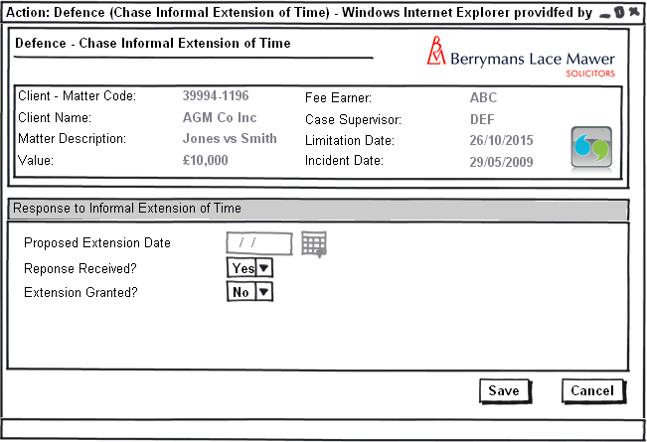 Figure 8 – Defence – Chase Informal Extension of Time

Form Availability
Form should not be available for selection adhoc from the Case Action screen but scheduled from Defence – How to Proceed.

Form Behaviour On Load
The form should load with Proposed Extension Date Pre-Populated via a New stored procedure LTMM_DefenceDetails_Fetch mapping to DefenceDetails_PrpsdExtnDate.

Form Items
Proposed Extension Date – Label as stated with associated Date Picker. This control should be read only.
Response Received? – Label as stated with associated Mandatory Combo box having the following options (Populated using LTMM_LookupCodes_Fetch with @LookupTypeCode = 'YesNo', @BlankRow = 1):
- Yes
- No
Extension Granted? – Label as stated with associated Combo box having the following options (Populated using LTMM_LookupCodes_Fetch with @LookupTypeCode = 'YesNo', @BlankRow = 1):
- Yes
- No
Control should only be visible if Response Received? =’Yes’ and should be mandatory if visible.

Form Behaviour on Submit
If Response received? = ‘No’ – Reschedule Defence – Chase Informal Extension of Time (Form 3) for the Lawyer on the Matter for 1 working day.

If Extension Granted? <> ‘’ – Schedule Defence – How to Proceed (Form 2) for the Lawyer on the Matter for the same day.

If Extension Granted? = ‘Yes’ – Update the Defence due date = Proposed Extension Date using LTMM_CaseKeyDates_Save.

If Extension Granted? = ‘Yes’ – Write History Line Informal Extension Request Granted by Claimant Solicitors

If Extension Granted? = ‘No’ – Write History Line Informal Extension Request Rejected by Claimant Solicitors.

Form Behaviour on Cancel
Return to Matter Landing Page

    - Defence – Draft Defence Received from Counsel (Form 4)

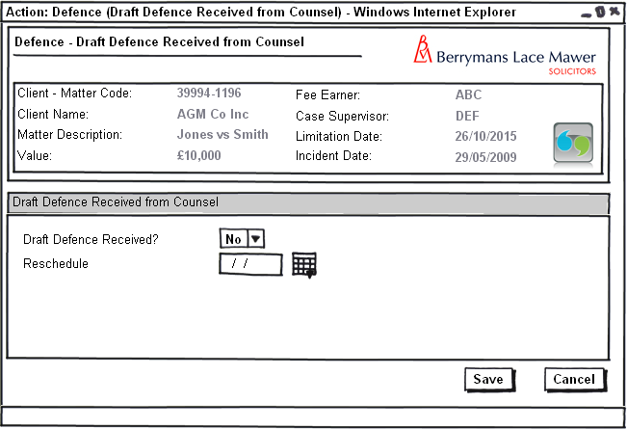 Figure 9 – Defence – Draft Defence Received from Counsel

Form Availability
Form should not be available for selection adhoc from the Case Action screen but scheduled from Defence – How to Proceed.

Form Behaviour On Load
The form should load without Pre-Populated data.

Form Items
Draft Defence Received? – Label as stated with associated Mandatory Combo box having the following options (Populated using LTMM_LookupCodes_Fetch with @LookupTypeCode = 'YesNo', @BlankRow = 1):
- Yes
- No
Reschedule – Label as stated with associated Date Picker. This control should only be visible if Draft Defence Received? = ’No’ and should be mandatory if visible.

Form Behaviour on Submit
If Draft Defence received? = ‘No’ – Reschedule Defence – Draft Defence Received from Counsel (Form 4) for the Team administrator on the Matter for the date entered in Reschedule.
If Draft Defence received? = ‘Yes’ – Schedule Defence – File Defence (Form 6) for the Lawyer on the Matter for the same day.

If Draft Defence received? = ‘Yes’ – Write History Line Draft Defence Received from Counsel

Form Behaviour on Cancel
Return to Matter Landing Page

    - Defence – (Re)Type Defence

Task without form *****UP TO HERE****

Task Behaviour on Execute
Should return to the Matter Landing Page.
Produce either a blank Draft Defence Document or a Pervious version of the Defence for typist to edit.
Schedule Defence – Review Typed Defence (Form 5) for the Lawyer on the Matter for the same day.

    - Defence – Review Typed Defence (Form 5)

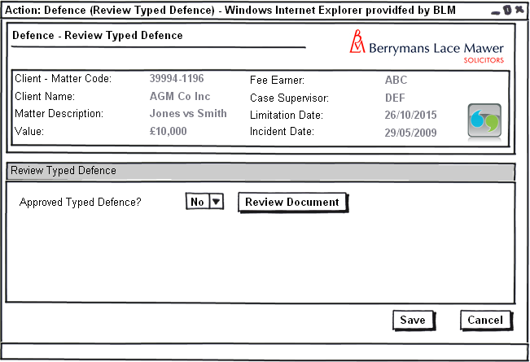 Figure 10 – Defence – Review Typed Defence

Form Availability
Form should not be available for selection adhoc from the Case Action screen but scheduled from Defence – (Re)Type Defence.

Form Behaviour On Load
The form should load without Pre-Populated data.

Form Items
Approved Typed Defence? – Label as stated with associated Mandatory Combo box having the following options (Populated using LTMM_LookupCodes_Fetch with @LookupTypeCode = 'YesNo', @BlankRow = 1):
- Yes
- No
Review Document – Button Labelled as stated. This control should load the typed defence in Word.

Form Behaviour on Submit
If Approved Typed Defence? = ‘No’ – Reschedule Defence – (Re)Type Defence for the Typing Queue.
If Approved Typed Defence? = ‘Yes’ – Schedule Defence – File Defence (Form 6) for the Lawyer on the Matter for the same day.

Form Behaviour on Cancel
Return to Matter Landing Page

    - Defence – File Defence (Form 6)

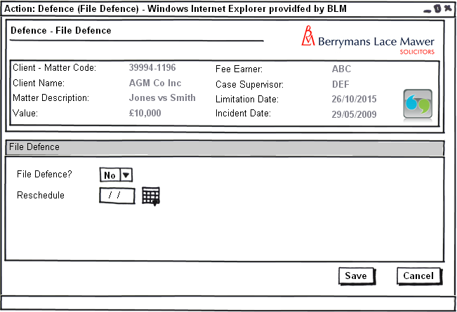 Figure 11 – Defence – File Defence

Form Availability
Form should not be available for selection adhoc from the Case Action screen but scheduled as part of the Defence flow as stated in this document.

Form Behaviour On Load
The form should load without Pre-Populated data.

Form Items
File Defence? – Label as stated with associated Mandatory Combo box having the following options (Populated using LTMM_LookupCodes_Fetch with @LookupTypeCode = 'YesNo', @BlankRow = 1):
- Yes
- No
Reschedule – Label as stated with associated Date Picker. This control should only be visible if File Defence? = ’No’ and should be mandatory if visible.

Form Behaviour on Submit
If File Defence? = ‘No’ – Reschedule Defence – File Defence for the Lawyer on the case for the date entered in Reschedule.
If File Defence? = ‘Yes’ – Schedule Allocation Questionnaire Received (Form 10) for the Team Administrator on the Matter for 5 working days.
If File Defence? = ‘Yes’ and Include Part 18 = Checked (entered on Defence – How to Proceed (Form 2)) – Part 18
If File Defence? = ‘Yes’ – Write History Line Defence Filed

Form Behaviour on Cancel
Return to Matter Landing Page

    - Defence – Draft Admission Received from Counsel (Form 7)

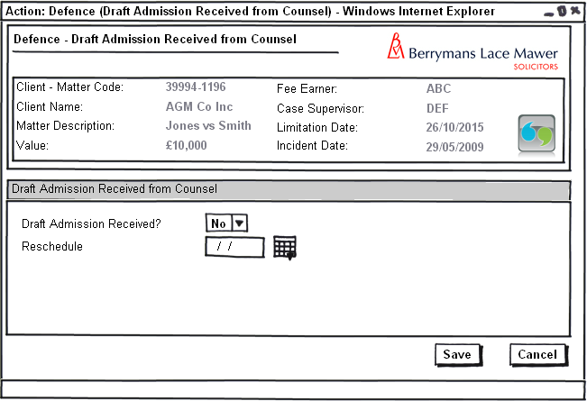 Figure 12 – Defence – Draft Admission Received from Counsel

Form Availability
Form should not be available for selection adhoc from the Case Action screen but scheduled from Defence – How to Proceed.

Form Behaviour On Load
The form should load without Pre-Populated data.

Form Items
Draft Admission Received? – Label as stated with associated Mandatory Combo box having the following options (Populated using LTMM_LookupCodes_Fetch with @LookupTypeCode = 'YesNo', @BlankRow = 1):
- Yes
- No
Reschedule – Label as stated with associated Date Picker. This control should only be visible if Draft Admission Received? = ’No’ and should be mandatory if visible.

Form Behaviour on Submit
If Draft Admission Received? = ‘No’ – Reschedule Defence – Draft Admission Received from Counsel (Form 7) for the Team administrator on the Matter for the date entered in Reschedule.
If Draft Admission received? = ‘Yes’ – Schedule Defence – File Admission (Form 9) for the Lawyer on the Matter for the same day.
If Draft Admission received? = ‘Yes’ – Write History Line Draft Admission Received from counsel

Form Behaviour on Cancel
Return to Matter Landing Page

    - Defence – (Re)Type Admission

Task without form

Task Behaviour on Execute
Should return to the Matter Landing Page.
Produce either a blank Draft Admission Document or a Pervious version of the Admission for typist to edit.
Schedule Defence – Review Typed Admission (Form 8) for the Lawyer on the Matter for the same day.

    - Defence – Review Typed Admission (Form 8)

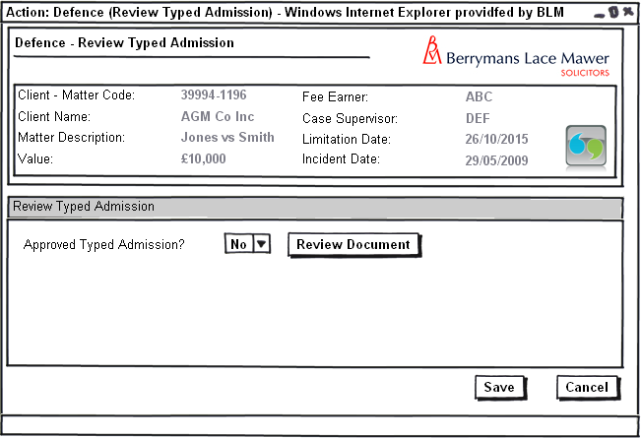 Figure 13 – Defence – Review Typed Admission

Form Availability
Form should not be available for selection adhoc from the Case Action screen but scheduled from Defence – (Re)Type Admission.

Form Behaviour On Load
The form should load without Pre-Populated data.

Form Items
Approved Typed Admission? – Label as stated with associated Mandatory Combo box having the following options (Populated using LTMM_LookupCodes_Fetch with @LookupTypeCode = 'YesNo', @BlankRow = 1):
- Yes
- No
Review Document – Button Labelled as stated. This control should load the typed admission in Word.

Form Behaviour on Submit
If Approved Typed Admission? = ‘No’ – Reschedule Defence – (Re)Type Admission for the Typing Queue.
If Approved Typed Admission? = ‘Yes’ – Schedule Defence – File Admission (Form 9) for the Lawyer on the Matter for the same day.

Form Behaviour on Cancel
Return to Matter Landing Page

    - Defence – File Admission (Form 9)

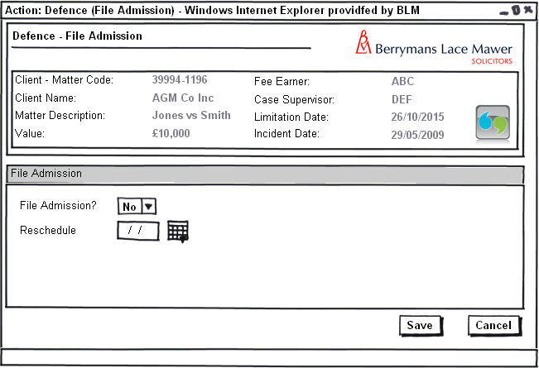 Figure 14 – Defence – File Admission

Form Availability
Form should not be available for selection adhoc from the Case Action screen but scheduled as part of the Defence flow as stated in this document.

Form Behaviour On Load
The form should load without Pre-Populated data.

Form Items
File Admission? – Label as stated with associated Mandatory Combo box having the following options (Populated using LTMM_LookupCodes_Fetch with @LookupTypeCode = 'YesNo', @BlankRow = 1):
- Yes
- No
Reschedule – Label as stated with associated Date Picker. This control should only be visible if File Admission? = ’No’ and should be mandatory if visible.

Form Behaviour on Submit
If File Admission? = ‘No’ – Reschedule Defence – File Admission for the Lawyer on the case for the date entered in Reschedule.
If File Admission? = ‘Yes’ – Schedule Allocation Questionnaire Received (Form 10) for the Team Administrator on the Matter for 5 working days.
If File Admission? = ‘Yes’ and Include Part 18 = Checked (entered on Defence – How to Proceed (Form 2)) – Part 18
If File Admission? = ‘Yes’ – Write History Line Admission Filed

Form Behaviour on Cancel
Return to Matter Landing Page

  - Allocation

    - Allocation Questionnaire Received (Form 10)

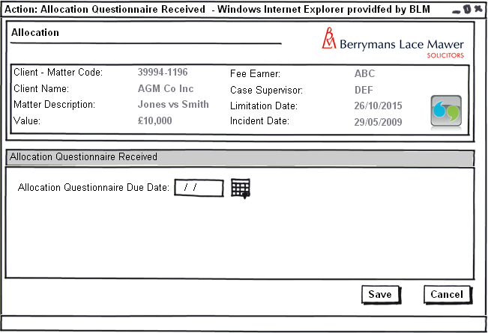 Figure 15 – Allocation Questionnaire Received

Form Availability
Form should be available for selection adhoc in addition to being scheduled from either Defence - File Defence (Form 6) or Defence - File Admission (Form 9).

Form Behaviour On Load
The form should load without Pre-Populated data.

Form Items
Allocation Questionnaire Due Date – as stated with associated Mandatory Date Picker

Form Behaviour on Submit
Upon submission schedule Allocation - Produce Allocation Questionnaire (Form 11) 5 working days before the Allocation Questionnaire Due Date entered on the form for the Lawyer on the Matter with Escalation to te hSupervisor on the Matter 2 days later.
Upon Submission use LTMM_CaseKeyDates_Save to save a new Key Date for the Allocation Questionnaire Due Date KeyDateCode = AlloQue

Form Behaviour on Cancel
Return to Matter Landing Page

    - Allocation - Produce Allocation Questionnaire (Form 11)

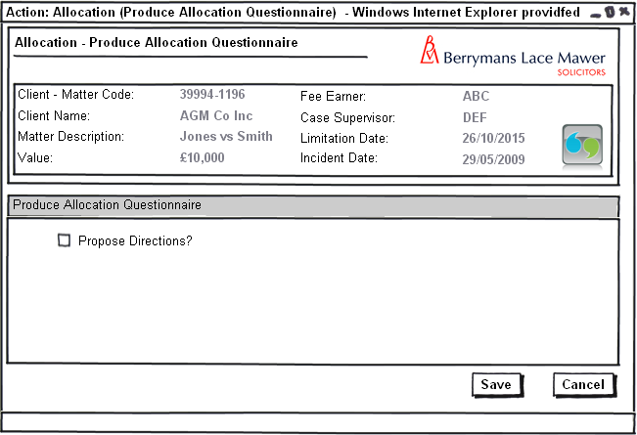
Figure 15 – Allocation Questionnaire Received

Form Availability
Form should not be available for selection adhoc but should be scheduled from Allocation Questionnaire Received (Form 10).

Form Behaviour On Load
The form should load without Pre-Populated data.

Form Items
Propose Directions? – Label as stated with associated Checkbox.

Form Behaviour on Submit
Upon submission the system should produce an Allocation Questionnaire for the Lawyer to complete.
If Propose Directions? = Checked upon submission the system should produce a Proposed Directions Form for the Lawyer to edit.

Form Behaviour on Cancel
Return to Matter Landing Page

  - Directions

    - Directions – Direction Tab

A new tab should be added to the FloCase systems that will allow Users to add and amend different Directions dates on an adhoc basis. This tab should resemble the following diagram:

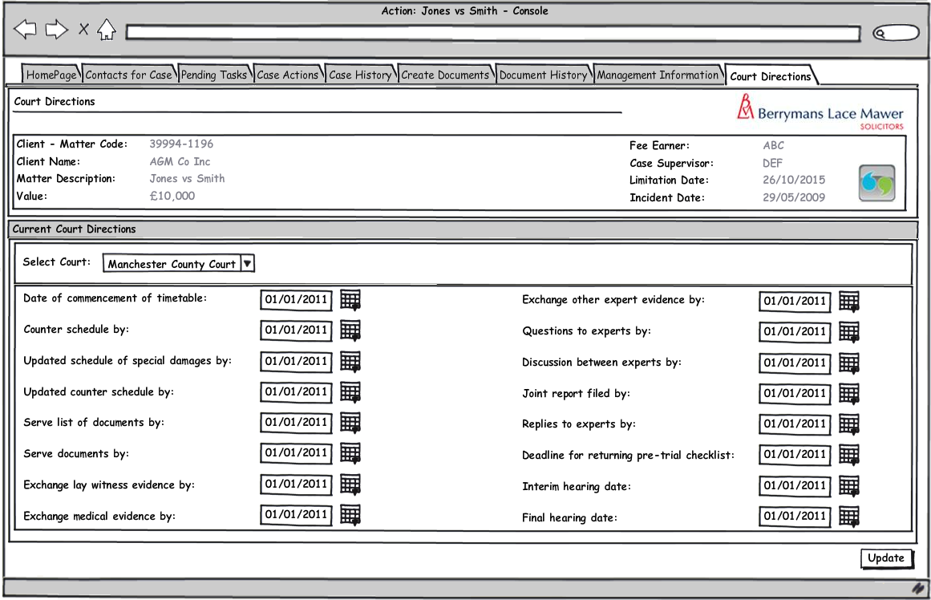 Figure 16 – Directions Tab

Form Availability
Form will be available at any time via the Case Console in its own Court Directions Tab.

Form Behaviour On Load
If their are no Court contacts attached to the matter then the following controls should be disabled:
- Select Court (Combo Box)
- Date of commencement of timetable (Date Picker)
- Counter schedule by (Date Picker)
- Updated schedule of special damages by (Date Picker)
- Updates counter schedule by (Date Picker)
- Serve list of documents by (Date Picker)
- Serve documents by (Date Picker)
- Exchange lay witness evidence by (Date Picker)
- Exchange medical evidence by (Date Picker)
- Exchange other expert witness evidence by (Date Picker)
- Questions to experts by (Date Picker)
- Discussion between experts by (Date Picker)
- Joint report to be filed by (Date Picker)
- Replies to experts by (Date Picker)
- Deadline for returning pre-trial checklist (Date Picker)
- Interim hearing date (Date Picker)
- Final hearing (trial) (Date Picker)

If there is only 1 Court Contact associated with the Matter then Select Court (Combo Box) should default to this Court and the following controls should default to any corresponding Key Dates attached to that case contact using a new Stored Procedure LTMM_Directions_Fetch:
- Date of commencement of timetable (Date Picker)
- Counter schedule by (Date Picker)
- Updated schedule of special damages by (Date Picker)
- Updates counter schedule by (Date Picker)
- Serve list of documents by (Date Picker)
- Serve documents by (Date Picker)
- Exchange lay witness evidence by (Date Picker)
- Exchange medical evidence by (Date Picker)
- Exchange other expert witness evidence by (Date Picker)
- Questions to experts by (Date Picker)
- Discussion between experts by (Date Picker)
- Joint report to be filed by (Date Picker)
- Replies to experts by (Date Picker)
- Deadline for returning pre-trial checklist (Date Picker)
- Interim hearing date (Date Picker)
- Final hearing (trial) (Date Picker)

Form Items
Select Court – Label as stated with associated Mandatory Combo box having the following options:
- All Active Court Contacts attached to the Matter populated via LTMM_CaseContacts_Fetch passing in contact type = ‘COURT’ and the CaseID of the matter being accessed
OnChange the screen should display the Directions associated with the selected court for the Matter being accessed using LTMM_Directions_Fetch passing the CaseID and the CaseContactID of the Court selected into @CourtCase_ContactID.
Date of commencement of timetable – Label as stated with associated Date Picker, associated with the key date with code CommTT Maps to Directions_DateComTmTble in LTMM_Directions_Fetch
Counter schedule by – Label as stated with associated Date Picker, associated with the key date with code Maps to CouSchd Directions_CntrSchdl in LTMM_Directions_Fetch
Updated schedule of special damages by – Label as stated with associated Date Picker, associated with the key date with code SchdDam Maps to Directions_UdtSchdlSDam in LTMM_Directions_Fetch
Updates counter schedule by – Label as stated with associated Date Picker, associated with the key date with code UCouSchd Maps to Directions_UptCntrSchdl in LTMM_Directions_Fetch
Serve list of documents by – Label as stated with associated Date Picker, associated with the key date with code ListDoc Maps to Directions_SrvLstDocs in LTMM_Directions_Fetch
Serve documents by – Label as stated with associated Date Picker, associated with the key date with code SrvDocs Maps to Directions_SrvDocs in LTMM_Directions_Fetch
Exchange lay witness evidence by – Label as stated with associated Date Picker, associated with the key date with code LWitEv Maps to Directions_ExLyWitEvid in LTMM_Directions_Fetch
Exchange medical evidence by – Label as stated with associated Date Picker, associated with the key date with code MExpEv Maps to Directions_ExMedWitEvid in LTMM_Directions_Fetch
Exchange other expert witness evidence by – Label as stated with associated Date Picker, associated with the key date with code OtWitEv Maps to Directions_ExOthrWitEvid in LTMM_Directions_Fetch
Questions to experts by – Label as stated with associated Date Picker, associated with the key date with code ExpQue Maps to Directions_QuesToExp in LTMM_Directions_Fetch
Discussion between experts by – Label as stated with associated Date Picker, associated with the key date with code ExpDis Maps to Directions_DiscBtwnExp in LTMM_Directions_Fetch
Joint report to be filed by – Label as stated with associated Date Picker, associated with the key date with code JntRep Maps to Directions_JntRep in LTMM_Directions_Fetch
Replies to experts by – Label as stated with associated Date Picker, associated with the key date with code ExpRep Maps to Directions_RplysToExp in LTMM_Directions_Fetch
Deadline for returning pre-trial checklist – Label as stated with associated Date Picker, associated with the new key date with code RPTCklst Maps to Directions_RetPreTrlChkLst in LTMM_Directions_Fetch
Interim hearing date – Label as stated with associated Date Picker, associated with the key date with code Hearing Maps to Directions_HrngDte in LTMM_Directions_Fetch
Final hearing (trial) – Label as stated with associated Date Picker, associated with the key date with code Trial Maps to Directions_TrlDte in LTMM_Directions_Fetch.
Update – Button with label as stated. Should only be enabled if a Court has been selected from Select Court.

Form Behaviour on Update
Upon Update of this form all the direction dates entered by the user associated with the selected Court contact should be updated using the new stored procedure LTMM_Directions_Save.
Upon Update of this form All existing Direction Reminder Tasks attached to the selected Court contact should be removed, this should be handled using the new stored procedure LTMM_Directions_Save.
Upon Update of this form a Direction Reminder Task for each Direction entered by the User should be scheduled, task texts to read as follows:
- Reminder: Date of commencement of timetable: <<Due Date>>
- Reminder: Counter schedule by: <<Due Date>>
- Reminder: Updated schedule of special damages by: <<Due Date>>
- Reminder: Updates counter schedule by: <<Due Date>>
- Reminder: Serve list of documents by: <<Due Date>>
- Reminder: Serve documents by: <<Due Date>>
- Reminder: Exchange lay witness evidence by: <<Due Date>>
- Reminder: Exchange medical evidence by: <<Due Date>>
- Reminder: Exchange other expert witness evidence by: <<Due Date>>
- Reminder: Questions to experts by: <<Due Date>>
- Reminder: Discussion between experts by: <<Due Date>>
- Reminder: Joint report to be filed by: <<Due Date>>
- Reminder: Replies to experts by: <<Due Date>>
- Reminder: Deadline for returning pre-trial checklist: <<Due Date>>
- Reminder: Interim hearing date: <<Due Date>>
- Reminder: Final hearing (trial): <<Due Date>>
Each task should be scheduled for 21 days prior to its due date with escalation to the case Supervisor 7 days before the due date. The task scheduling should be handled using the new stored procedure LTMM_Directions_Save.
Upon Update the form should return the user to the Matter Landing page.

    - Directions – Direction Reminder Task

Task without form

Task Behaviour on Execute
Should return to the Matter Landing Page.

Workflow

  - File Defence (See 3.1 Defence for more detailed descriptions.)

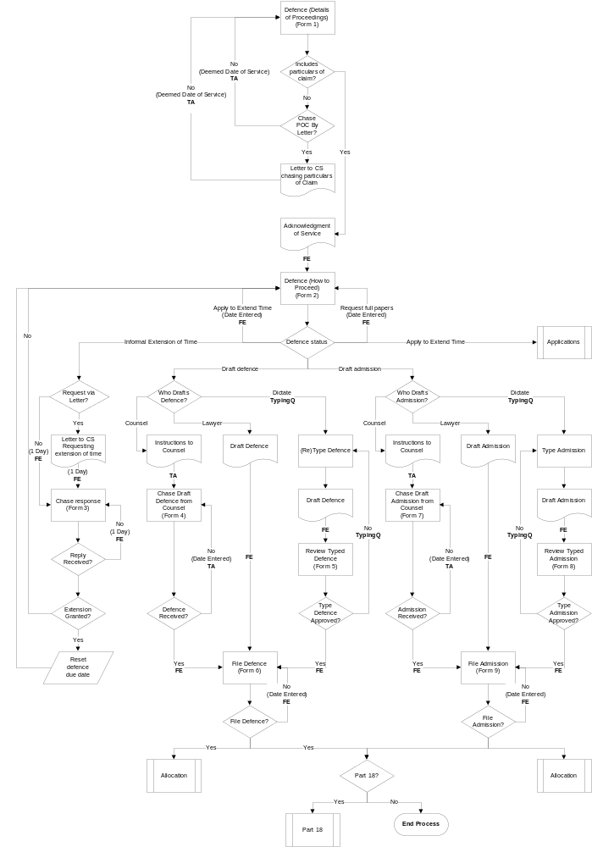
  - Allocation

Additional Workflow to handle filing an allocation questionnaire is described in the diagram below.

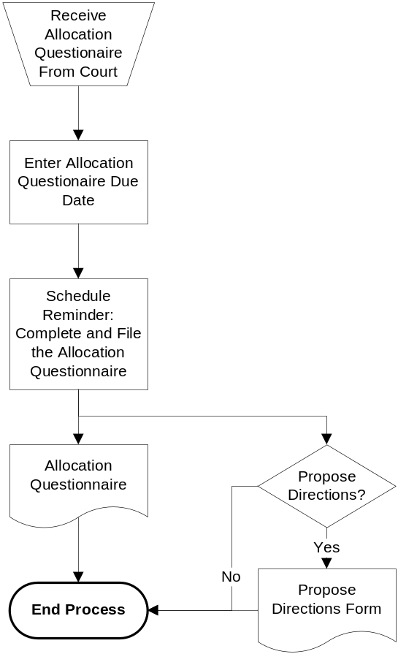

In the above diagram the Reminder should be scheduled for the Fee Earner 5 working days before the Allocation Questionnaire Due date entered on the new Allocation Form with escalation to the team leader 2 working days before this date.

  - Directions
The new tab for Court Directions allows the user to enter due dates for the following Directions received from the Court state:
- Date of commencement of timetable
- Counter schedule by
- Updated schedule of special damages by
- Updates counter schedule by
- Serve list of documents by
- Serve documents by
- Exchange lay witness evidence by
- Exchange medical evidence by
- Exchange other expert witness evidence by
- Questions to experts by
- Discussion between experts by
- Joint report to be filed by
- Replies to experts by
- Deadline for returning pre-trial checklist
- Interim hearing date
- Final hearing (trial)

When a user enters or amends one of these dates the system should use the following process to add a reminder task for the Direction(s) that the user has modified (Replace [Direction] with the name of the Direction 1-15 above that the flow applies to).

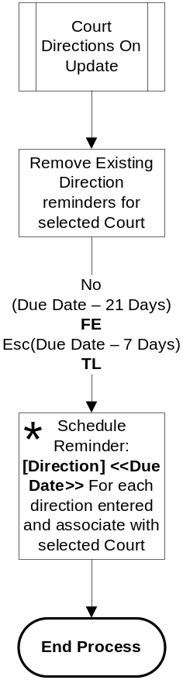

In the above diagram the Reminder should be scheduled for the Fee Earner 21 days before the [Direction] Due date entered for all the Directions listed 1-15 above with escalation to the team leader 7 days before the due date.

Note: the Schedule Reminder process is an iterative process for each Direction entered by the user hence being denoted with an asterisk.

Navigation

Where will the Flow be launched from

Each of the follows for Defence, Allocation and Directions will be handled as Follows:
- Defence – Upon the user submitting the task detailed in Section 31.1 the system will launch the defence work flow as detailed sections 3.1 (Detailed) and 4.1 (Overview).
- Allocation – Will commence upon the user either selection and running the Allocation questionnaire received activity from the Case Actions screen or Filing a Defence or an Admission as detailed sections 3.1/3.2 (Detailed) and 4.1/4.2 (Overview).
- Directions – Upon the user enter or modifying any of the direction dates on the new directions tab the system will launch the directions work flow as detailed section 4.3 specific to the Directions amended.

Where should the Flow return to

All work flows should return as follows:
- Defence – Defendant on stage (see section 3.1)
- Allocation – Defendant on stage (see section 3.2).
- Directions – Matter Landing Page.

SQL Tables

Table

DefenceDetails

DefenceDetails_DefenceDetailsID – Int Not Null (PK)
DefenceDetails_CaseID – Int Not Null

DefenceDetails_Code – Bit Default 0

DefenceDetails_POCRec – Bit Default 0

DefenceDetails_DefStatus – Varchar(255) Null
DefenceDetails_Part18 – Bit Default 0
DefenceDetails_PrpsdExtnDate – SmallDateTime

DefenceDetails_InActive – Bit Default 0

DefenceDetails_CreateUser – Varchar(255) Not Null
DefenceDetails_CreateDate – SmallDateTime Default GetDate()

Lookup

Defence

New lookup for Defence Status having a LookupTypeCode of DEFSTAT with the following options:
- Draft Defence
- Draft Admission
- Informal Extension of Time
- Apply for Extension of Time
- Request Full File of Papers

New lookup for Who will Draft having a LookupTypeCode of DOCDRAFT with the following options:
- Counsel
- Lawyer
- Dictate

    - Allocation

The following new key date type are required:
- Allocation Questionnaire due date with a Key Date Code of AlloQue

    - Directions

The following new key date type are required:
- Deadline for Returning pre-trial checklist with a Key Date Code of RPTCklst

Field

n/a

Stored Procedures

Fetch

    - Defence

LTMM_DefenceDetails_Fetch.

Inputs:
@CaseID – Mandatory CaseID for the Matter being accessed Type int
@UserName – Mandatory map to system username type Varchar(255)

OutPuts:

DefenceDetails_Code

DefenceDetails_POCRec

DefenceDetails_DefStatus
DefenceDetails_Part18

DefenceDetails_PrpsdExtnDate
DefenceDetails_DDService (Fetch From Deemed Date of Service Key Date)
DefenceDetails_DateIssue (Fetch From Date of Issue Key Date)
DefenceDetails_DefDueDate (Fetch From Defence Due Date Key Date)
DefenceDetails_DateJdgEntrd (Fetch From Date Judgement Entered Key Date)

    - Allocation

n/a

    - Directions

LTMM_Directions_Fetch

Inputs:
@CaseID – Mandatory CaseID for the Matter being accessed Type int
@CourtCase_ContactID Type int
@UserName – Mandatory map to system username type Varchar(255)

Outputs:
Directions_DateComTmTble (Fetch From Date of commencement of timetable Key Date)
Directions_CntrSchdl (Fetch From Counter schedule by Key Date)
Directions_UdtSchdlSDam (Fetch From Updated schedule of special damages by Key Date)
Directions_UptCntrSchdl (Fetch From Updates counter schedule by Key Date)
Directions_SrvLstDocs (Fetch From Serve list of documents by Key Date)
Directions_SrvDocs (Fetch From Serve documents by Key Date)
Directions_ExLyWitEvid (Fetch From Exchange lay witness evidence Key Date) by
Directions_ExMedWitEvid (Fetch From Exchange medical evidence by Key Date)
Directions_ExOthrWitEvid (Fetch From Exchange other expert witness evidence by Key Date)
Directions_QuesToExp (Fetch From Questions to experts by Key Date)
Directions_DiscBtwnExp (Fetch From Discussion between experts by Key Date)
Directions_JntRep (Fetch From Joint report to be filed by Key Date)
Directions_RplysToExp (Fetch From Replies to experts by Key Date)
Directions_RetPreTrlChkLst (Fetch From Deadline for returning pre-trial checklist Key Date)
Directions_HrngDte (Fetch From Interim hearing date Key Date)
Directions_TrlDte (Fetch From Final hearing (trial) Key Date)

Save

    - Defence

LTMM_DefenceDetails_Save

Inputs:

@pDefenceDetails_Code type Varchar(255) – Input A

@pDefenceDetails_POCRec type bit – Input B

@pDefenceDetails_DefStatus type Varchar(255) – Input C
@pDefenceDetails_Part18 type bit – Input D
@pDefenceDetails_PrpsdExtnDate type smalldatetime – Input E
@CaseID – Mandatory CaseID for the Matter being accessed Type int – Input F
@UserName – Mandatory map to system username type Varchar(255) – Input G
@pDefenceDetails_DDService (Save to Deemed Date of Service Key Date) type smalldatetime – Input H
@pDefenceDetails_DateIssue (Save to Date of Issue Key Date) type smalldatetime – Input I
@pDefenceDetails_DefDueDate (Save to Defence Due Date Key Date) type smalldatetime – Input J
@pDefenceDetails_DateJdgEntrd (Save to Date Judgement Entered Key Date) type smalldatetime – Input K

Note: Save should preserve existing data that is not passed.

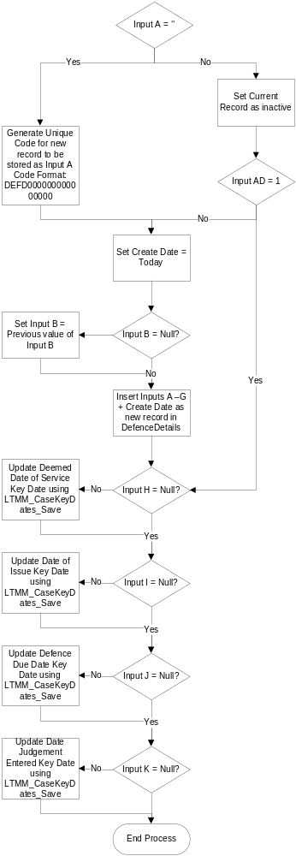

    - Allocation

Upon submission of the new Allocation Questionnaire received task the system will invoke the LTMM_CaseKeyDates_Save passing it the following parameters:
- @pCaseKeyDates_CaseID = <<CaseID of the current matter>>
- @pCaseKeyDates_Date = <<Allocation Questionnaire Due Date as entered on the Allocation Questionnaire received task >>
- @pCaseKeyDates_KeyDatesCode = AlloQue

Subsequently the Allocation Questionnaire due date will be saved/updated by the stored procedure against the matter. This should also update any Outlook tasks connected to this date if and when they change.

Note: There should only be one date of type Allocation Questionnaire due date attached to a matter at any one time so the stored procedure needs to ensure that if one already exists then it updates the pre-existing one otherwise it enters a new one.

    - Directions

LTMM_Directions_Save

Inputs:
@CaseID – Mandatory CaseID for the Matter being accessed Type int – Input A
@CourtCase_ContactID Mandatory Type int – Input B
@UserName – Mandatory map to system username type Varchar(255) – Input C
@Directions_DateComTmTble (Fetch From Date of commencement of timetable Key Date) – Input D
@Directions_CntrSchdl (Fetch From Counter schedule by Key Date) – Input E
@Directions_UdtSchdlSDam (Fetch From Updated schedule of special damages by Key Date) – Input F
@Directions_UptCntrSchdl (Fetch From Updates counter schedule by Key Date) – Input G
@Directions_SrvLstDocs (Fetch From Serve list of documents by Key Date) – Input H
@Directions_SrvDocs (Fetch From Serve documents by Key Date) – Input I
@Directions_ExLyWitEvid (Fetch From Exchange lay witness evidence Key Date) by – Input J
@Directions_ExMedWitEvid (Fetch From Exchange medical evidence by Key Date) – Input K
@Directions_ExOthrWitEvid (Fetch From Exchange other expert witness evidence by Key Date) – Input L
@Directions_QuesToExp (Fetch From Questions to experts by Key Date) – Input M
@Directions_DiscBtwnExp (Fetch From Discussion between experts by Key Date) – Input N
@Directions_JntRep (Fetch From Joint report to be filed by Key Date) – Input O
@Directions_RplysToExp (Fetch From Replies to experts by Key Date) – Input P
@Directions_RetPreTrlChkLst (Fetch From Deadline for returning pre-trial checklist Key Date) – Input Q
@Directions_HrngDte (Fetch From Interim hearing date Key Date) – Input R
@Directions_TrlDte (Fetch From Final hearing (trial) Key Date) – Input S

Output:
@returnvalue = 1

For each direction the stored procedure must either create a new stored procedure and reminder task if one doesn’t exist or update the existing key date and reschedule the reminder based on the new date. Using the following process

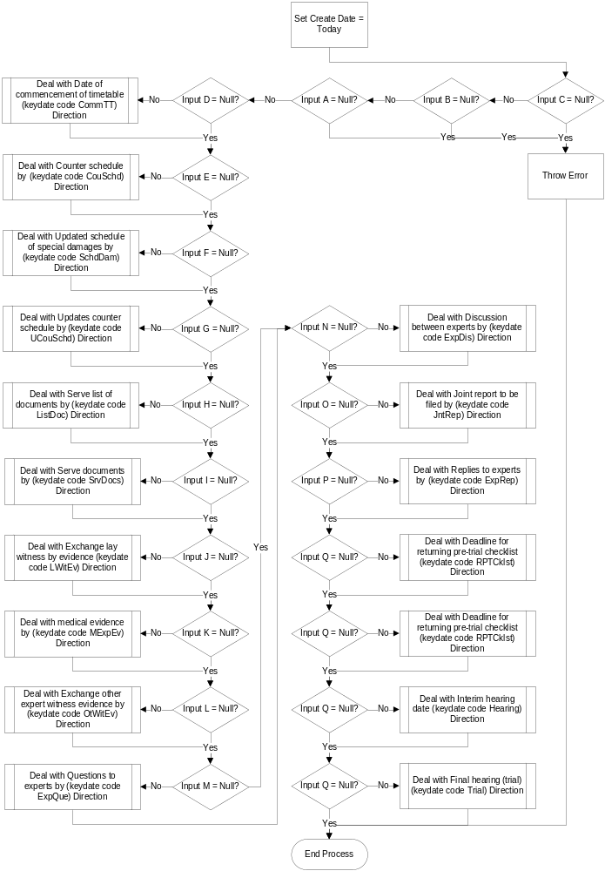

Deal with Direction process is as follows

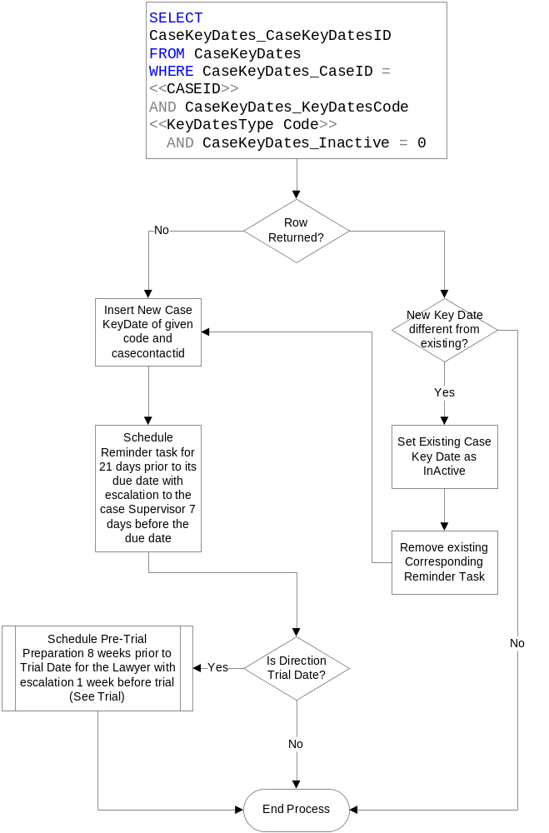

Document Templates

Please list below details of any document required as part of this scope.

Status:  New / Existing / Replacement  (please state) | Received Document Name (from business) | Document File Name  (ie Document.dot) | Document Description  (as viewed on FloCase) | Template Description Code  (Code for auto description) | Template Group:  BLM/ Documents/ Court Doc/ Letters/ Other  (Please State)
Existing | Acknowledgment of Service | Court_N9_AcknowlegeOfService.dot | Acknowledgment of Service | Ack. Serv. | Court Documents
Existing | Adhoc letter to Claimant Solicitor | BLM_Letter.dot | BLM Letter Template | Ltr. | BLM
New | Instructions to Counsel Letter | 50) Ad-hoc letter to Counsel enclosing instructions.rtf | Letter to Counsel Enclosing Instructions | Tbc | Letters
Existing | Draft Defence Document | Court_N11_Defence.dot | Defence | Def. | Court Documents
Existing | Draft Admission Document | Court_N11_Defence.dot | Defence | Def. | Court Documents
Existing | Allocation Questionnaire | Court_N150_Allocation  Questionnaire.dot | Allocation Questionnaire | Al. Quest. | Court Documents
New | Proposed Directions Form | 29) Suggested Directions.rtf | Suggested Directions | Tbc | Court Documents

/tmp/lo/0000.doc

